**Name:** Anandan Sundar **NET ID:** axs156730

**ASSIGNMENT 1 - REPORT**

**Question 2:**

The price data was loaded for AMZN(Amazon), DJIA (Dow Jones Industrial Average), SPY(S&P 500) , AAPL(Apple Corp), BAC (Bank of America), NFLX(Netflix) and PCLN(Priceline) and the following information was obtained while following buy & hold and SMA crossover strategy.

The output was generated and charts were plotted using chartseries functions. It will be found in loadSIT.R and Ques2_training.R files.

|  |  |  |  |  |  |  |
| --- | --- | --- | --- | --- | --- | --- |
| Stock | Buy and Hold | | | SMA Crossover | | |
|  | CAGR | Performance |  | CAGR | Performance |  |
|  |  | Best | Worst |  | Best | Worst |
| AMZN | 13.5 | 35.5 | -24.8 | 16.7 | 26.9 | -16.6 |
| DJIA | 2.7 | 11.1 | -7.9 | 1.6 | 3.9 | -3.6 |
| SPY | 2.1 | 14.5 | -9.8 | 3.7 | 4.4 | -3.9 |
| AAPL | -0.4 | 13.9 | -85.5 | 9.2 | 13.2 | -85.5 |
| BAC | -6.4 | 35.3 | -49.9 | -6.8 | 6.7 | -49.9 |
| NFLX | 15.2 | 42.2 | -8.6 | 24.4 | 42.2 | -8.6 |
| PCLN | 22.2 | 494.8 | -42.3 | 23.8 | 494.8 | -39.8 |

The plots for the above mentioned stocks are in the following order:

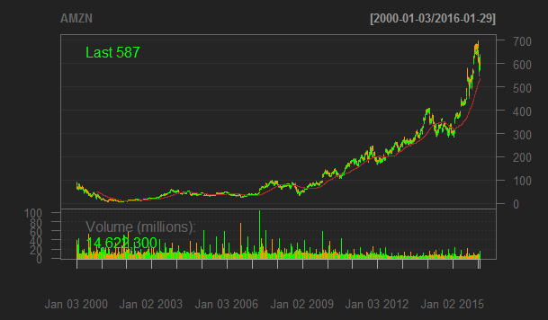

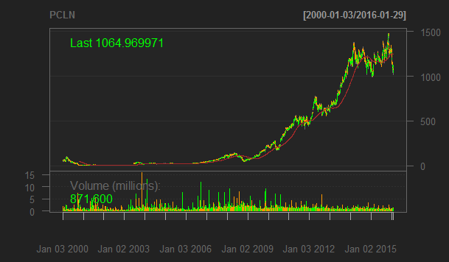

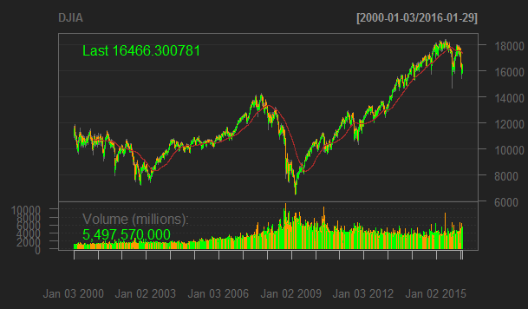

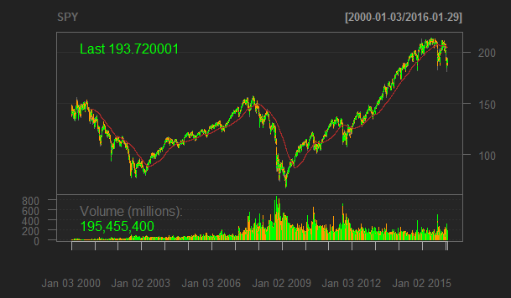

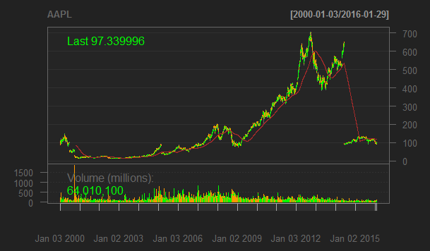

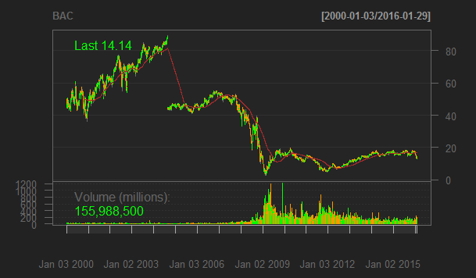

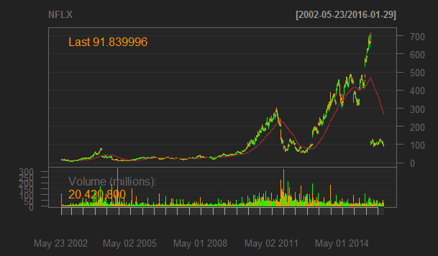



From these charts and the table, we can conclude that SMA cross over strategy can be followed for Amazon, SPY, Apple, Netflix and PriceLine. It is because we see that the value of stock increases when we perform buying and selling operations. Overall the value of stock increases from the base price as well. This will lead us to gain some profit. However, Buy and Hold strategy can be followed for DJIA and Bank of America. The value of stock decreases from the base price. Hence keeping the stock without performing any transactions will ensure that the user does not gain any loss.

SMA cross over strategy (Ranked based on descending order of CAGR): NFLX, PCLN, AMZN, AAPL, SPY, DGIA, and BAC

Buy and Hold strategy (Ranked based on descending order of CAGR): PCLN, NFLX, AMZN, DGIA, SPY, AAPL, and BAC.